Please consider including one of these inserts that can be pasted right into your bulletin. (Electronic copies of these insert samples can be found at www.dio.org//restoredorder)

DID YOU KNOW….
THIS PARISH WILL SOON OFFER CONFIRMATION PRIOR TO FIRST HOLY COMMUNION??

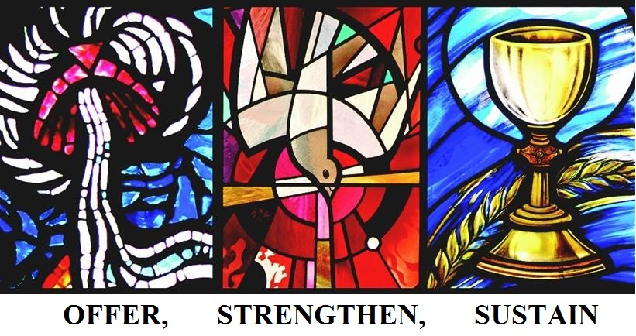

Indeed, all parishes within the Diocese of Springfield in Illinois are restoring the Original Order of the Sacraments of Initiation between 2019-2025.

In the early Church, the person was immersed into the waters of Baptism, anointed with chrism, and shared in the Eucharistic meal as part of a single event. Over time, and for many reasons, the celebration of these three sacraments became separated from one another. In the renewal stemming from the Second Vatican Council, the Church was asked to more clearly set forth the intimate connection of Confirmation with the whole of Christian initiation. This original order also helps us recognize that sharing in the Eucharist completes our initiation into the Church and that it is Eucharist which is the “source and summit of our faith.”

Go to https://www.dio.org/restoredorder for more information on this important change.

DID YOU KNOW…. THIS PARISH WILL SOON OFFER THE SACRAMENT OF CONFIRMATION PRIOR TO FIRST HOLY COMMUNION??

Indeed, all parishes within the Diocese of Springfield in Illinois are restoring the Original Order of the Sacraments of Initiation between 2019-2025.

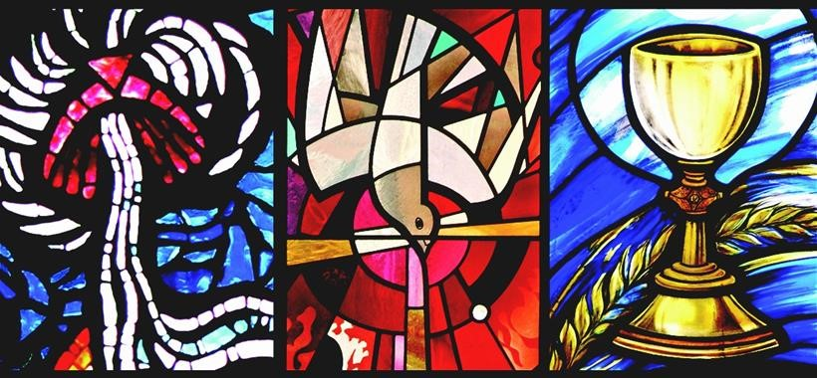

Go to www.dio.org/restoredorder to learn how the Sacraments of Baptism, Confirmation and First Holy Communion were celebrated in the early church, how it changed over time and why we are called to restore these sacraments to their original order.

