Seeking: Full-Time Certified Preschool Teacher
for the 2022-23 School Year

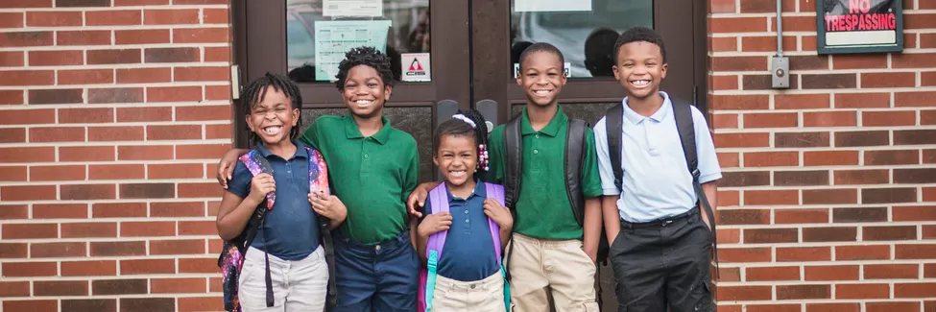
St. Patrick Catholic Elementary School
1800 South Grand Avenue, Springfield, IL 62703

https://st-patrick.org

Pre-K Teacher Responsibilities:
- Maintaining student safety under the school behavior plan
- Teaching students according to the social-emotional and educational curriculum
- Promoting safety, respect, responsibility, and healthy relationships

Benefits:
- Full time Classroom Aide!
- Salary commensurate with experience as well as benefits
- 7:30 AM-3:30 PM, 2022-23 school year (August 15th start date)

A successful candidate will:
- Be a certified Pre-K educator in the state of Illinois
- Pass all required background checks
- Love young children and have experience in early childhood education

To apply, send your resume and cover letter with reference contact information to Principal Michael Carlson: mcarlson@st-patrick.org

